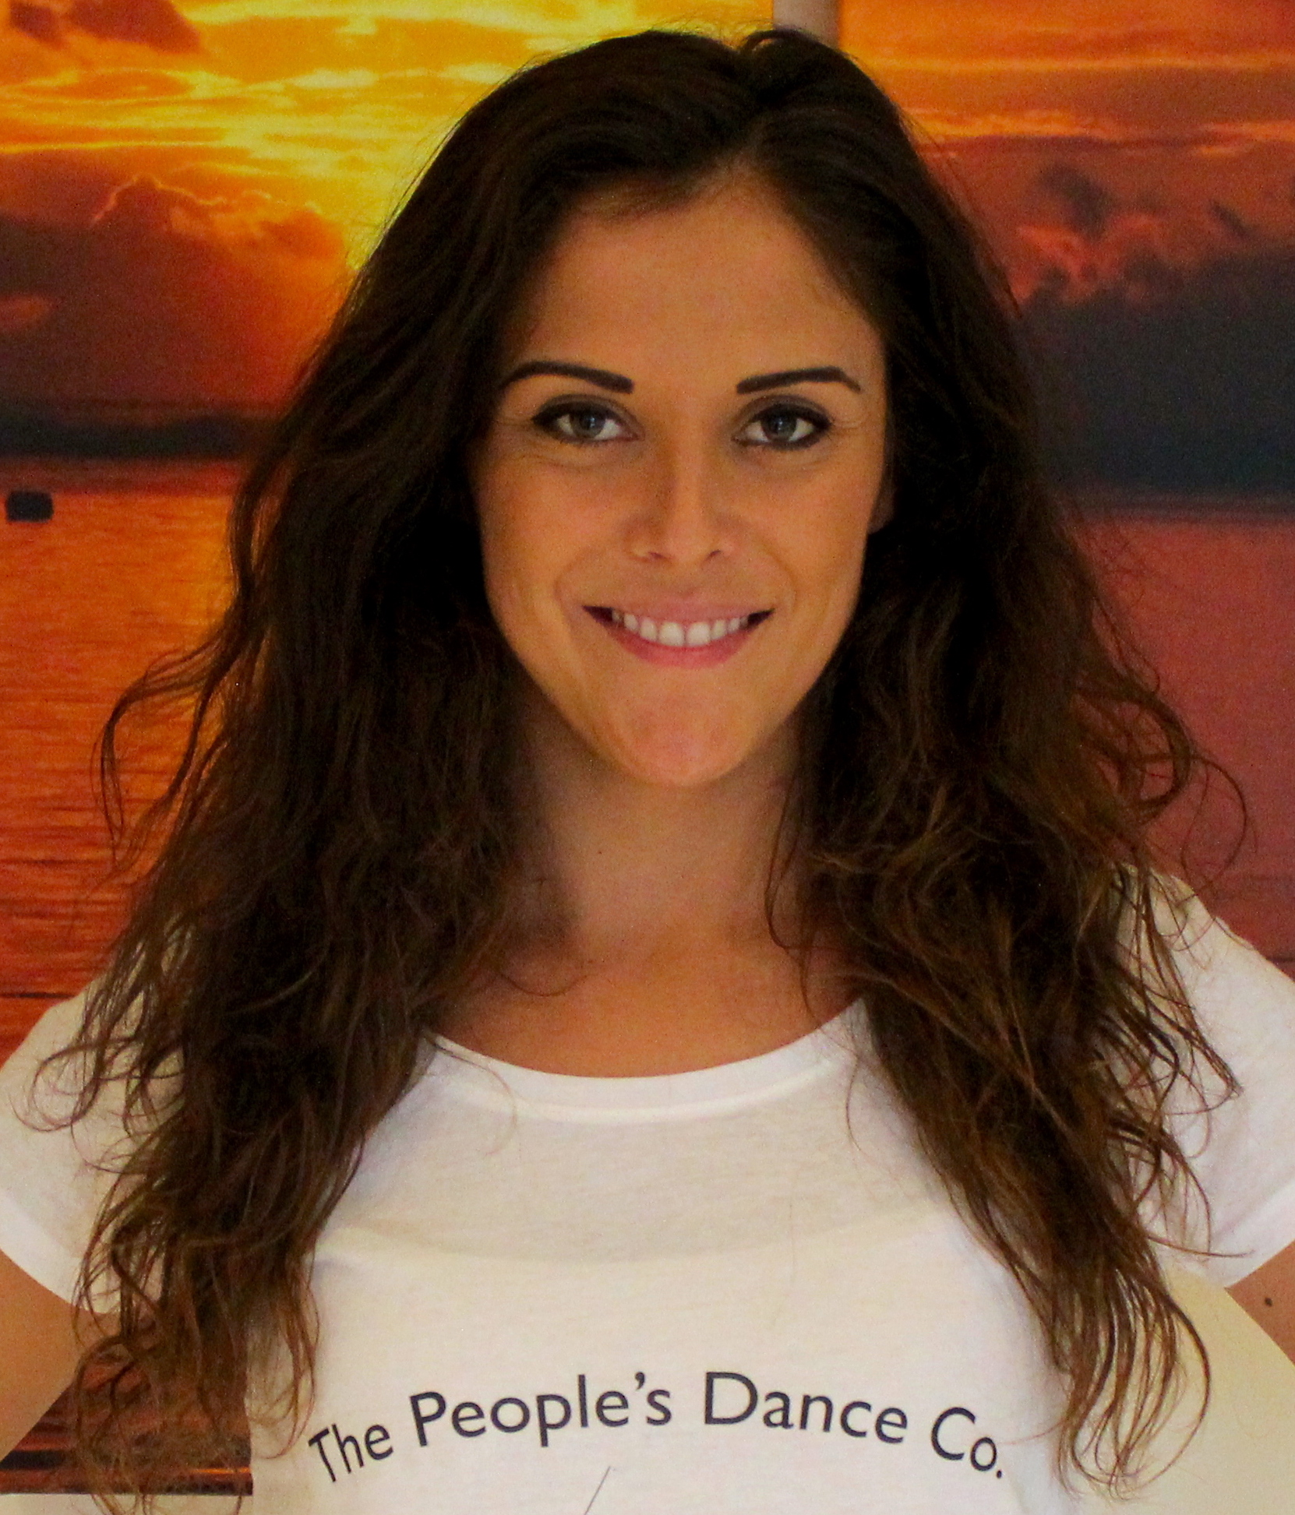

Beckie Davis

Director of The People’s Dance Company

Beckie Davis is the proud founder and director of The People’s Dance Company and Fitness with Friends.

She has worked professionally in the performing arts industry for many years touring as a Dancer, Dance Captain and Lead role of ‘Spirit’ with the well-known Irish show Spirit of the Dance. These tours include: Russia, Israel, Europe, UK, Canada, China and Dubai.

She has also performed in the resident shows on board the M/S Carnival Sensation and M/S Carnival Liberty with Carnival Cruise Lines.

Beckie has various TV credits including The London 2012 Olympic Opening Ceremony, as a backing dancer/ choreographer at Wembley Arena, The X Factor Israel and CBBC’s Hetty Feather.

Apart from her vast experience in dance teaching and performing, she is also a fully qualified Personal Trainer and Fitness Instructor.

Beckie is delighted to be back home and sharing her passion with others through The People’s Dance Company.